**Companies are required to report a description of the methodologies used to calculate emissions for each scope 3 category**

The business goals most frequently cited by companies as reasons for developing a scope 3 inventory were to: (1) identify and understand the risks and opportunities associated with value chain emissions; (2) identify GHG reduction opportunities, set reduction targets, and track performance; and (3) engage value chain partners in GHG management.

To start the screening, a company can apply the criteria in table II to each of the 15 categories to find out where the bulk of its scope 3 GHG emissions occur

To facilitate the initial screening, companies can use the less specific calculation methods listed for each category (i.e., the methods at the bottom of the decision trees).

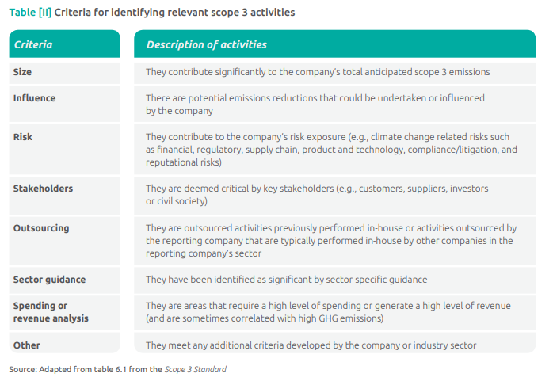

Calculating emissions requires the use of two types of data: activity data and emission factors.

“Activity data” is a quantitative measure of a level of activity that results in GHG emissions (for example, liters of fuel consumed, or kilograms of material purchased).

An “emission factor” is a factor that converts activity data into GHG emissions data (for example kg CO2 emitted per liter of fuel consumed, or kg CO2 emitted per kilograms of material produced).

**Companies are required to report a description of the types and sources of activity data and emission factors used to calculate the inventory**

Two types of emission factors can be used for calculating emissions associated with a material or product:

* Life cycle emission factors, which include emissions that occur at every stage of a material/product’s life, from raw material acquisition or generation of natural resource to end of life
* Cradle-to-gate (sometimes referred to as “upstream”) emission factors, which include all emissions that occur in the life cycle of a material/product up to the point of sale by the producer.

In general, cradle-to-gate emission factors should be used to calculate emissions associated with goods or services (e.g. category 1 (Purchased goods and services) and category 2 (Capital goods).

Companies may either use the Intergovernmental Panel on Climate Change (IPCC) GWP values agreed to by United Nations Framework Convention on Climate Change (UNFCCC) or the most recent GWP values published by the IPCC. GWP values should be based on a 100-year time horizon.

**Companies are required to disclose the source of GWP values used to calculate the inventory**

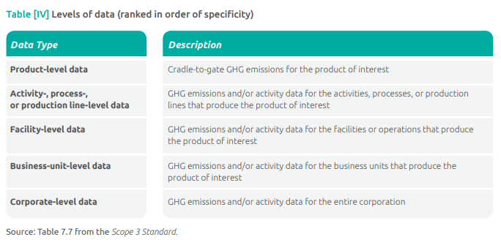

When using secondary databases, companies should prefer those that are internationally recognized, provided by national governments, or peer-reviewed.

The output of EEIO (environmentally-extended input output) models is typically a quantity of GHGs emitted per unit of revenue in a particular industry sector. For example, an EEIO model may estimate that the sector “paper mills” emits 1,520 tonnes CO2 e per $1 million revenue, meaning that, on average, 1,520 tonnes of CO2 e are emitted during all upstream supply chain activities associated with generating $1 million revenue from that sector.

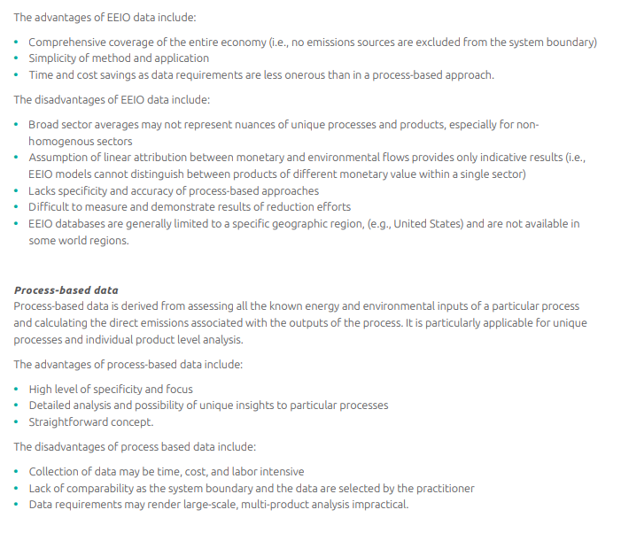

Companies may combine the top down EEIO approach with the bottom-up, process-based approach to leverage the benefits of both approaches. For example, the upstream emissions of purchased goods could be calculated using an EEIO approach, whereas downstream emissions from use and end-of-life could be calculated using a process-based approach.

**Companies are required to report a description of the types and sources of data used to calculate emissions for each scope 3 category**

Proxy data is data from a similar activity that is used as a stand-in for the given activity. Proxy data can be extrapolated, scaled up, or customized to be more representative of the given activity (e.g., partial data for an activity can be extrapolated or scaled up to represent 100 percent of the activity).

If a large company has access to 80 out of 100 manufacturing facilities it can extrapolate this information to fill the gap. It would first group the activity data by similar characteristics, such as facility type or location, then calculate an intensity ratio for a group of facilities where data is available (e.g., quantity of emissions per unit of production output). This figure can then be applied to the unknown facilities in that group.

If data are unavailable for a large number of sites or if a company needs to collect a large quantity of data for a scope 3 category, but finds it impractical or impossible to collect data from each individual activity, the company may use appropriate sampling techniques to extrapolate data from a representative sample of activities. **See Appendix A for guidance on sampling methods**.

Over time, companies should seek to improve the data quality of the inventory by replacing lower quality data with higher quality data as it becomes available. In particular, companies should prioritize data quality improvement for activities that have: • Relatively low data quality • Relatively high emissions.

**Companies are required to provide a description of the data quality of reported scope 3 emissions data to ensure transparency and avoid misinterpretation of data**

If changes in data quality result in significant differences in emissions estimates, companies are required to recalculate base year emissions applying the new data sources. Appendix C of the Scope 3 Standard also provides a useful resource for developing a data management plan and improving data management

[**https://ghgprotocol.org/calculation-tools-and-guidance**](https://ghgprotocol.org/calculation-tools-and-guidance)

**Categories:**

# 1, Purchased Goods and Services

This category includes all upstream (i.e., cradle-to-gate) emissions from the production of products purchased or acquired by the reporting company in the reporting year. Products include both goods (tangible products) and services (intangible products).

The first two methods – supplier-specific and hybrid – require the reporting company to collect data from the suppliers, whereas the second two methods – average-data and spend-based – use secondary data (i.e. industry average data). These methods are listed in order of how specific2 the calculation is to the individual supplier of a good or service. However, companies need not always use the most specific method as a first preference

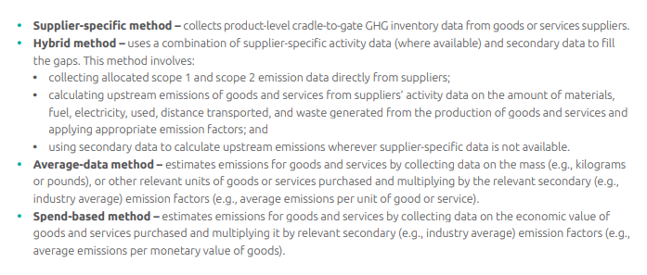

Even though the supplier-specific and hybrid methods are more specific to the individual supplier than the average-data and spend-based methods, they may not produce results that are a more accurate reflection of the product’s contribution to the reporting company’s scope 3 emissions. In fact, data collected from a supplier may actually be less accurate than industry-average data for a particular product.

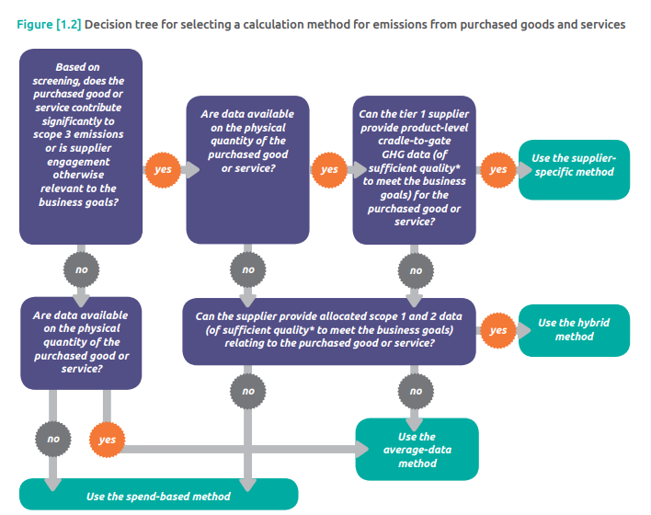

Average-data method

In this method, the company collects data on the mass or other relevant units of purchased goods or services and multiplies them by relevant secondary (e.g., industry average) cradle-to-gate emission factors. Secondary emission factors may be found in process-based life cycle inventory databases. **Refer to “Secondary data sources” in the Introduction for further guidance on these databases.**

Activity data needed

* Mass or number of units of purchased goods or services for a given year (e.g., kg, hours spent).

Emission factors needed

* Cradle-to-gate emission factors of the purchased goods or services per unit of mass or unit of product (e.g., kg CO2 e/kg or kg CO2 e/hour spent).

Data collection guidance

Data sources for activity data include:

* Internal data systems (e.g., bill of materials)
* Purchasing records.

Data sources for emission factors include:

* Process life cycle databases
* Industry associations.

Companies should assess both the age of the database (i.e., temporal representativeness) and the geographic relevance to the supplier’s location (e.g., geographical representativeness), as well as the technological representatives, completeness, and reliability of the data.

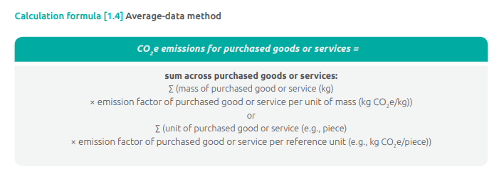

Spend-based method

If the supplier-specific method, hybrid method, and average-data method are not feasible (e.g., due to data limitations), companies should apply the average spend-based method by collecting data on the economic value of purchased goods and services and multiplying them by the relevant EEIO emission factors. Refer to the “Secondary data sources” in the Introduction for further guidance on EEIO data.

Activity data needed

* Amount spent on purchased goods or services, by product type, using market values (e.g., dollars)
* Where applicable, inflation data to convert market values between the year of the EEIO emissions factors and the year of the activity data.

Emission factors needed

* Cradle-to-gate emission factors of the purchased goods or services per unit of economic value (e.g., kg CO2 e/$).

Data collection guidance Data sources for activity data include:

* Internal data systems (e.g., enterprise resource planning (ERP) systems)
* Bill of materials
* Purchasing records.

Data sources for emission factors include:

* Environmentally-extended input-output (EEIO) databases
* Industry associations.

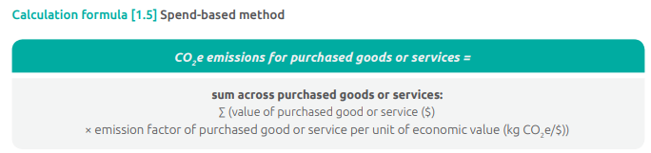

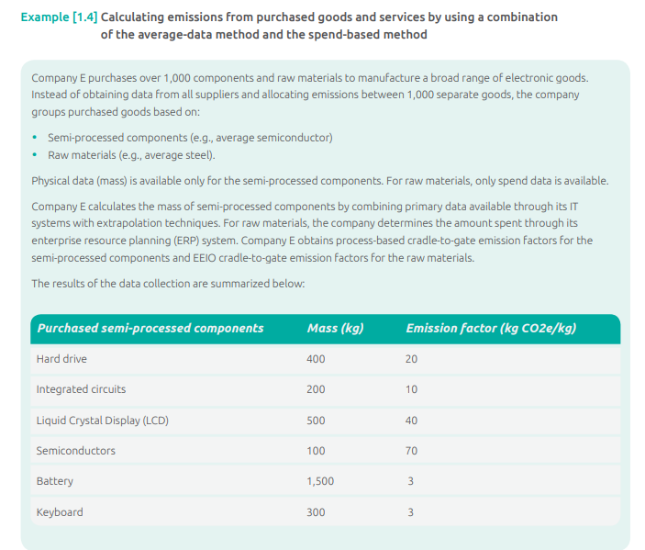

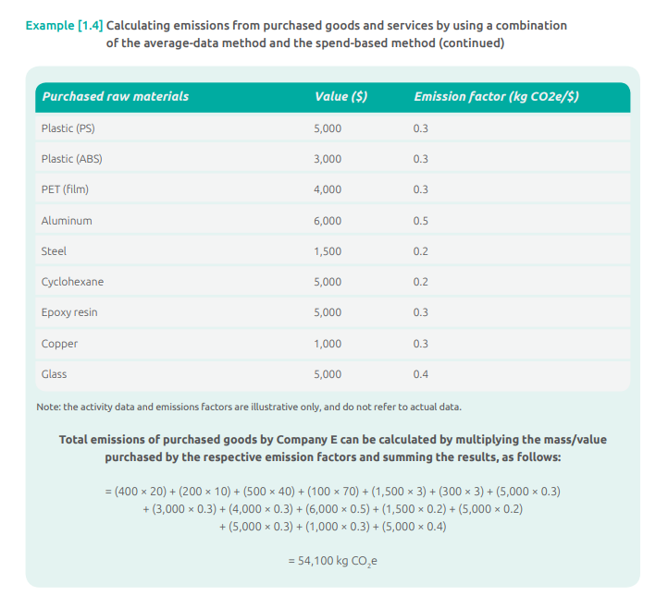

# 2, Capital Goods

This category includes all upstream (i.e., cradle-to-gate) emissions from the production of capital goods purchased or acquired by the reporting company in the reporting year. Emissions from the use of capital goods by the reporting company are accounted for in either scope 1 (e.g., for fuel use) or scope 2 (e.g., for electricity use), rather than in scope 3.

If major capital purchases occur only once every few years, scope 3 emissions from capital goods may fluctuate significantly from year to year. **Companies should provide appropriate context in the public report (e.g., by highlighting exceptional or non-recurring capital investments).**

**The calculation methods for category 1 (Purchased goods and services) and category 2 (Capital goods) are the same.**

# 3, Fuel and Energy Related Activities Not Included in Scope 1 or Scope 2

This category includes emissions related to the production of fuels and energy purchased and consumed by the reporting company in the reporting year that are not included in scope 1 or scope 2

Category 3 excludes emissions from the combustion of fuels or electricity consumed by the reporting company because they are already included in scope 1 or scope 2.

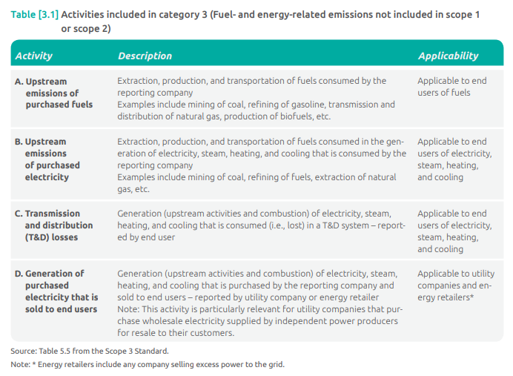

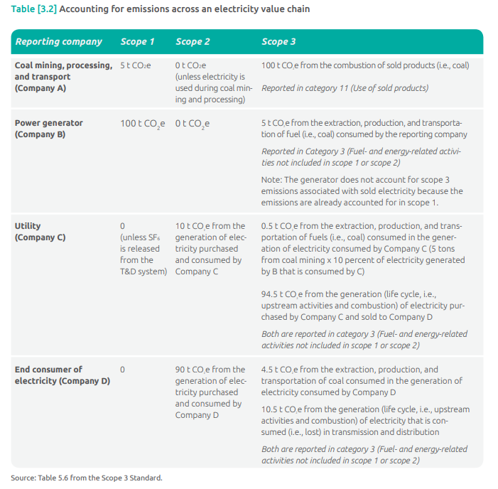

Calculating upstream emissions of purchased fuels (activity A of table 3.1) This activity includes the extraction, production, and transportation of fuels consumed by the reporting company. Companies may use either of the following methods to calculate scope 3 emissions from upstream emissions of purchased fuels:

* Supplier-specific method, which involves collecting data from fuel providers on upstream emissions (extraction, production and transportation) of fuel consumed by the reporting company
* Average-data method, which involves estimating emissions by using secondary (e.g., industry average) emission factors for upstream emissions per unit of consumption (e.g., kg CO2 e/kWh).

Activity data needed Companies should collect data on: • Quantities and types of fuel consumed.

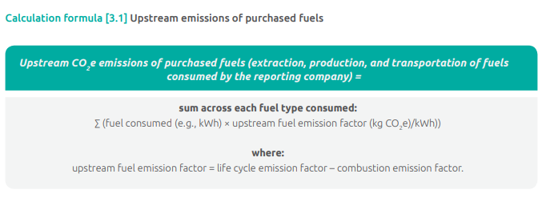  
If possible, the combustion and life cycle emission factors should be from the same temporal, technical, and geographic representativeness

Calculating upstream emissions of purchased electricity (activity B of table 3.1)

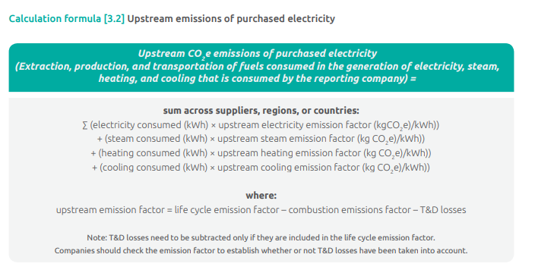

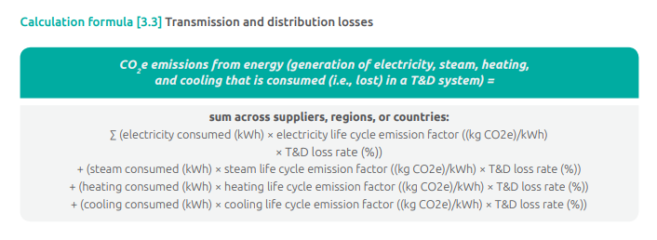

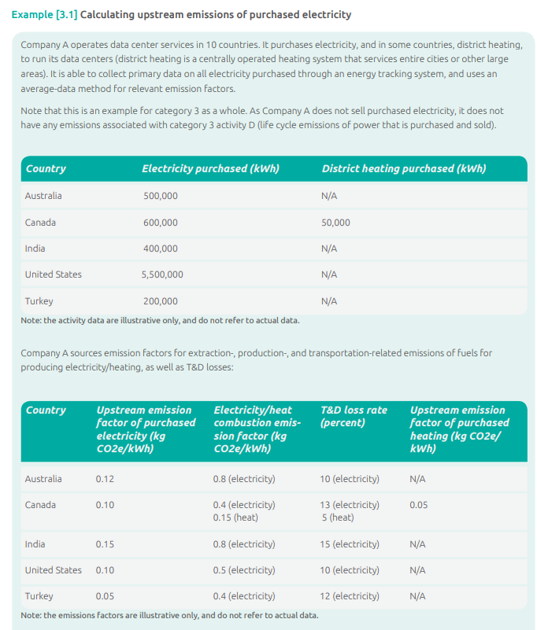

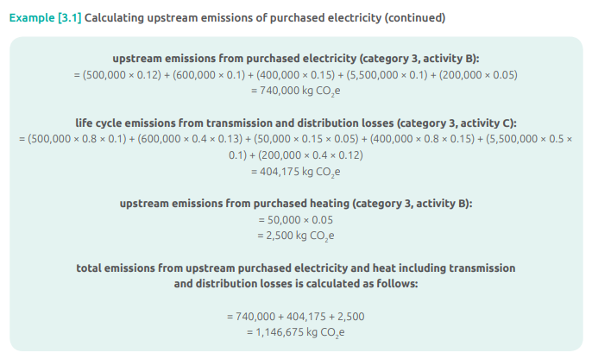

Calculating life cycle emissions from power that is purchased and sold (activity D in table 3.1)

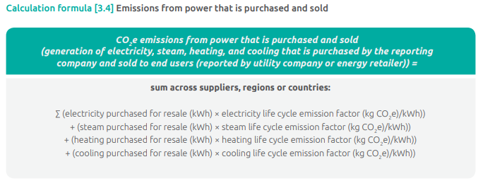

4, Upstream Transportation and Distribution

Category 4 includes emissions from:

* Transportation and distribution of products purchased in the reporting year, between a company’s tier 1 suppliers3 and its own operations in vehicles not owned or operated by the reporting company (including multi-modal shipping where multiple carriers are involved in the delivery of a product, but excluding fuel and energy products)
* Third-party transportation and distribution services purchased by the reporting company in the reporting year (either directly or through an intermediary), including inbound logistics, outbound logistics (e.g., of sold products), and third-party transportation and distribution between a company’s own facilities.

Emissions may arise from the following transportation and distribution activities throughout the value chain:

* Air transport
* Rail transport
* Road transport
* Marine transport
* Storage of purchased products in warehouses, distribution centers, and retail facilities.

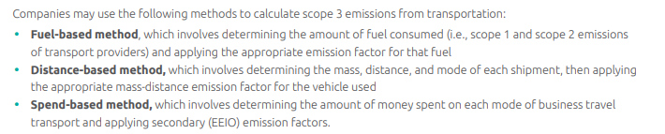

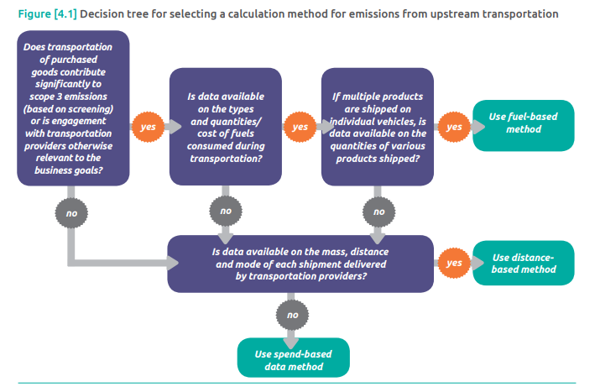

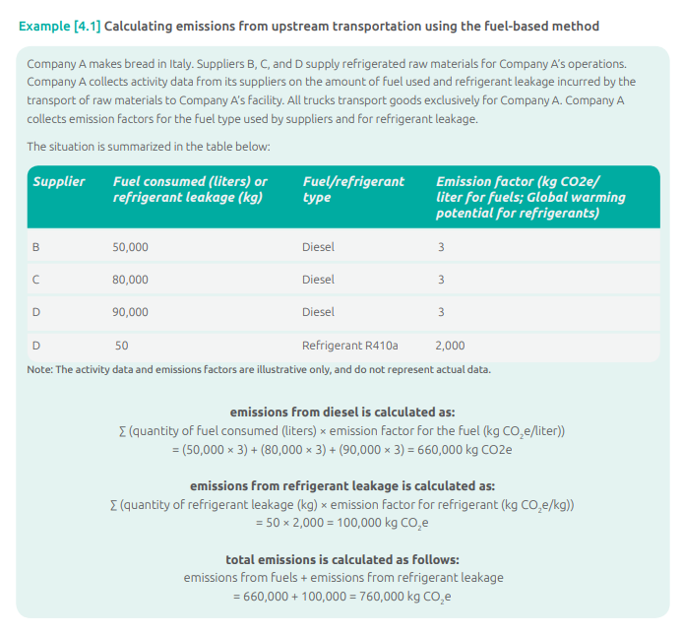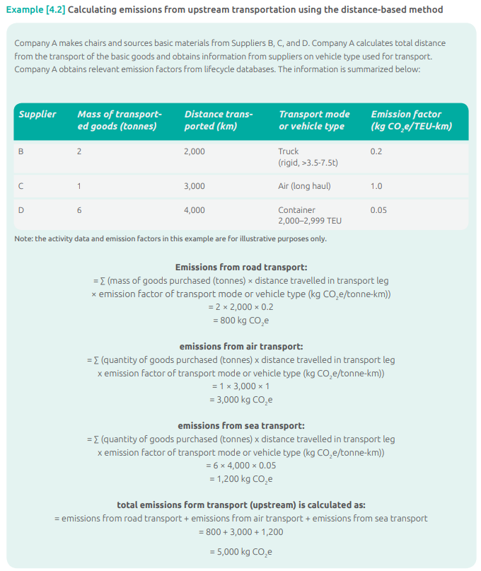

**Spend-based method**

If the fuel-based method and distance method cannot be applied (e.g., due to data limitations), companies should apply the spend-based method to calculate the emissions from transportation. In this method, the amount spent on transportation by type is multiplied by the relevant EEIO emission factors. Refer to “Environmentally-extended input output (EEIO) data” in the Introduction for guidance on EEIO data. Companies may determine the amount spent on transportation through bills, invoice payments, or financial accounting systems. The spend-based method is effective for screening purposes; however it has high levels of uncertainty and the fuel-based and distance-based methods are recommended for accounting for transportation emissions.

Activity data needed

* Amount spent on transportation by type (e.g. road, rail, air, barge), using market values (e.g., dollars).

Environmentally-extended input-output (EEIO) databases. A list of EEIO databases is provided on the GHG Protocol website (http://www.ghgprotocol.org/Third-Party-Databases). Additional databases may be added periodically, so continue to check the website.

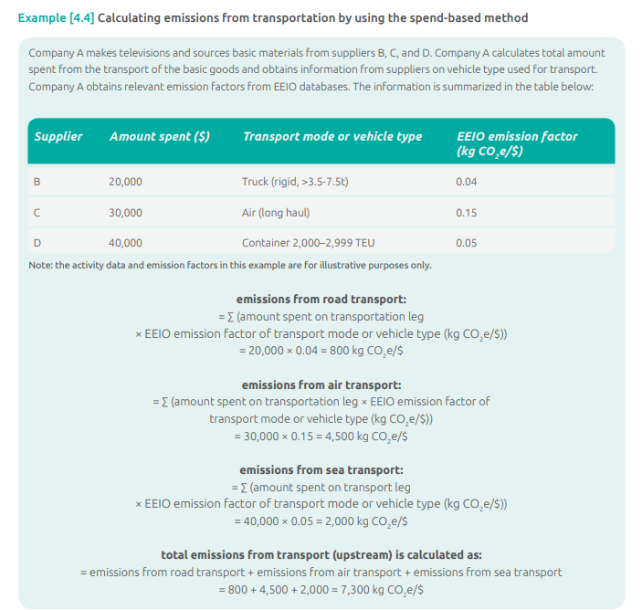

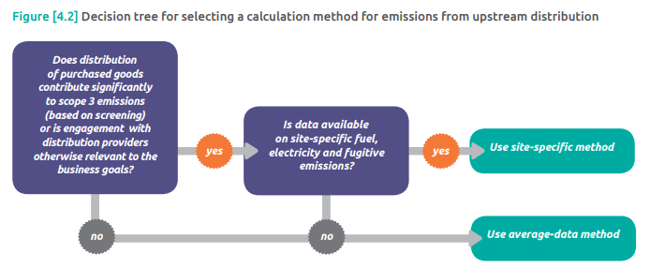

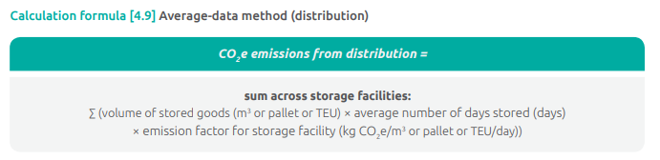

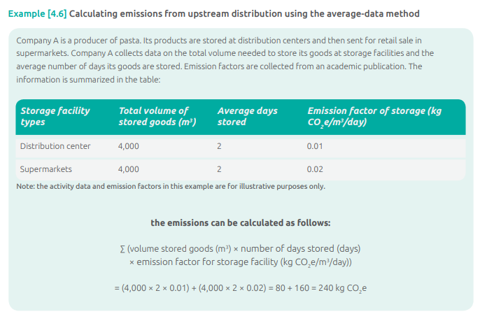

# 5, Waste Generated in Operations

Category 5 includes emissions from third-party disposal and treatment of waste generated in the reporting company’s owned or controlled operations in the reporting year. This category includes emissions from disposal of both solid waste and wastewater

* **Supplier-specific method**, which involves collecting waste-specific scope 1 and scope 2 emissions data directly from waste treatment companies (e.g., for incineration, recovery for recycling)
* **Waste-type-specific method**, which involves using emission factors for specific waste types and waste treatment methods
* **Average-data method**, which involves estimating emissions based on total waste going to each disposal method (e.g., landfill) and average emission factors for each disposal method.

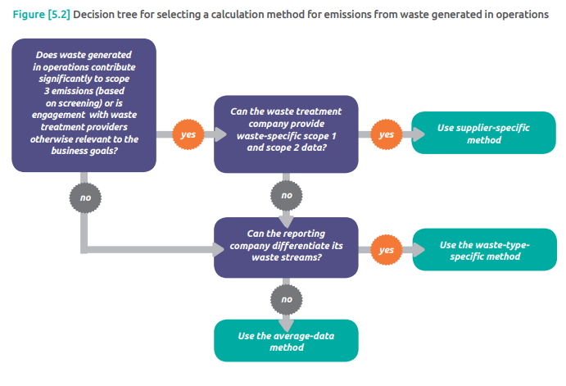

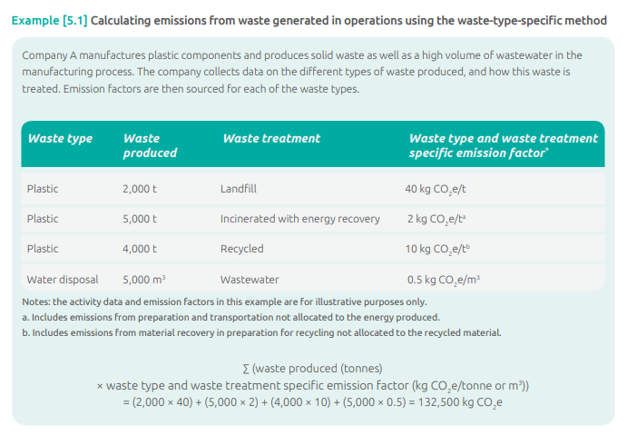

Average-data method Companies using the average-data method should collect data based on the total waste diversion rates from the reporting organization. This is often preferable where the type of waste produced is unknown. However, this method has a higher degree of uncertainty than the waste-type-specific method

Activity data needed Companies should collect:

* Total mass of waste generated in operations
* Proportion of this waste being treated by different methods (e.g., percent landfilled, incinerated, recycled).

Because many waste operators charge for waste by disposal method, this data may be collected from utility bills. The information may also be stored on internal IT systems.

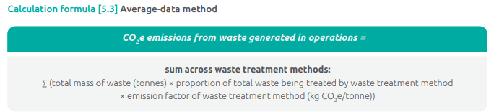

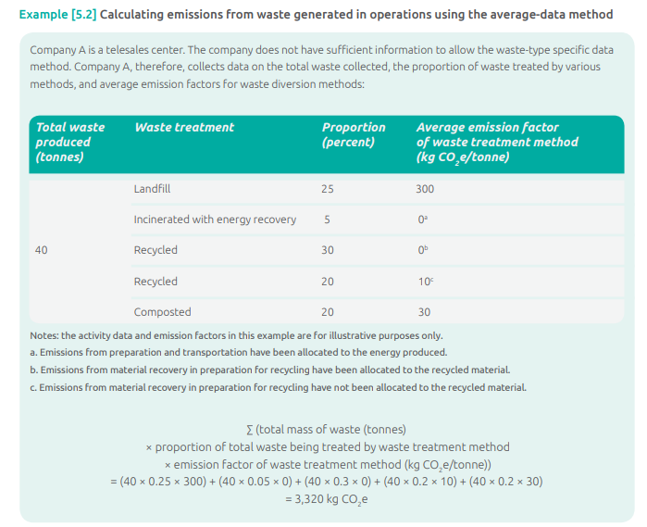

# 6, Business Travel

This category includes emissions from the transportation of employees for business related activities in vehicles owned or operated by third parties, such as aircraft, trains, buses, and passenger cars.

A reporting company’s scope 3 emissions from business travel include the scope 1 and scope 2 emissions of transportation companies (e.g., airlines).

* **Fuel-based method,** which involves determining the amount of fuel consumed during business travel (i.e., scope 1 and scope 2 emissions of transport providers) and applying the appropriate emission factor for that fuel
* **Distance-based method,** which involves determining the distance and mode of business trips, then applying the appropriate emission factor for the mode used
* **Spend-based method,** which involves determining the amount of money spent on each mode of business travel transport and applying secondary (EEIO) emission factors.

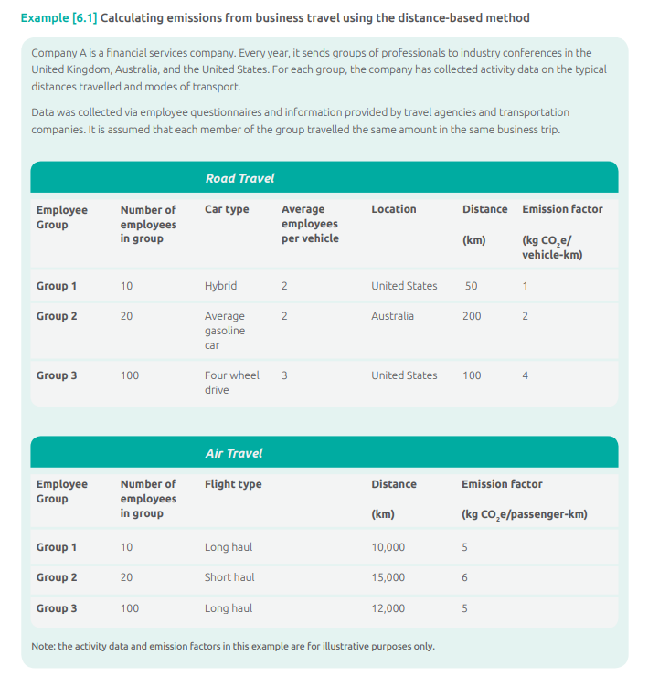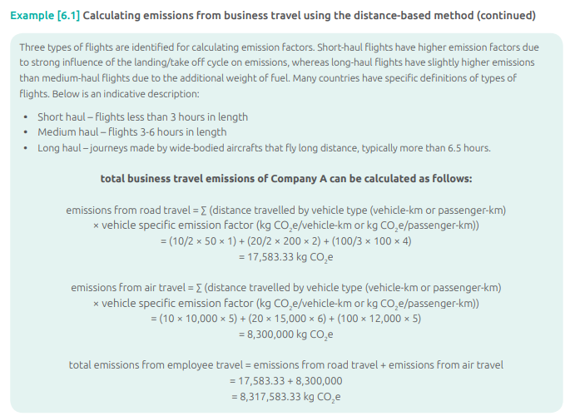

# 7, Employee Commuting

This category includes emissions from the transportation of employees4 between their homes and their worksites

A reporting company’s scope 3 emissions from employee commuting include the scope 1 and scope 2 emissions of employees and third-party transportation providers.

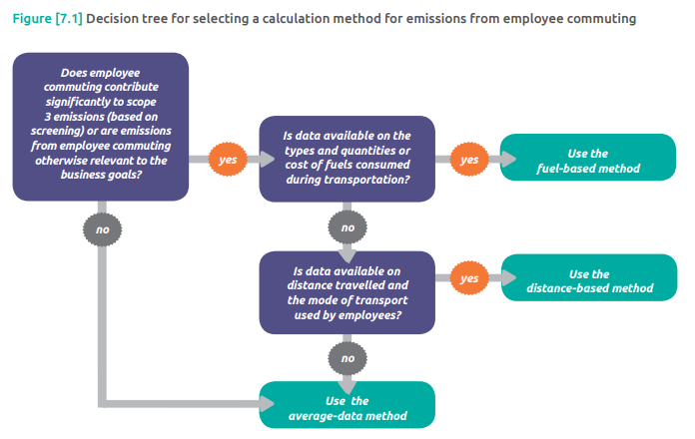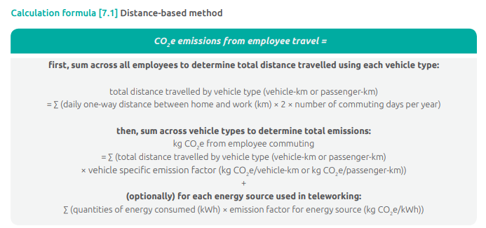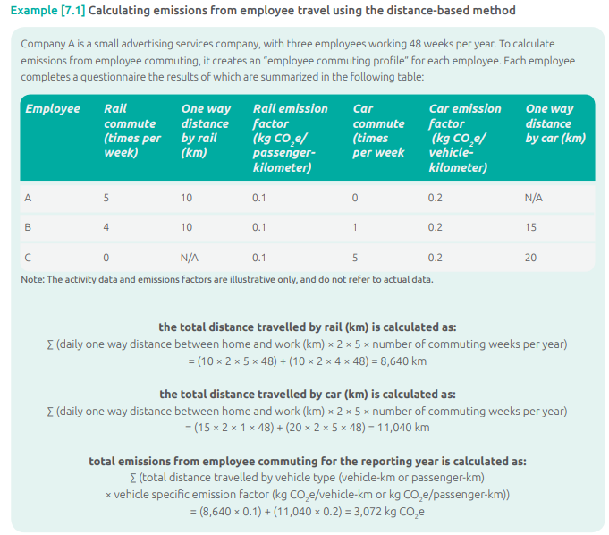

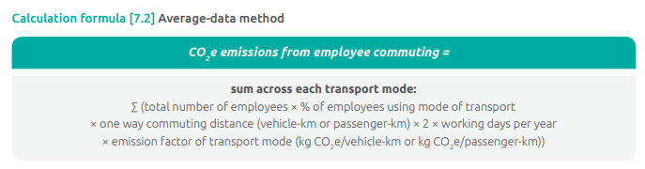

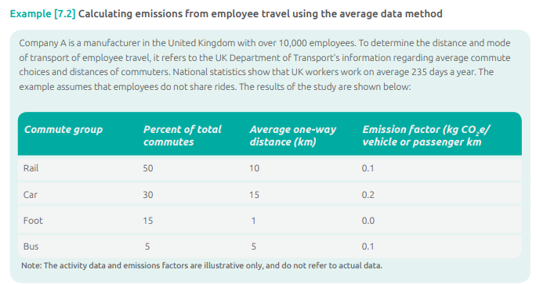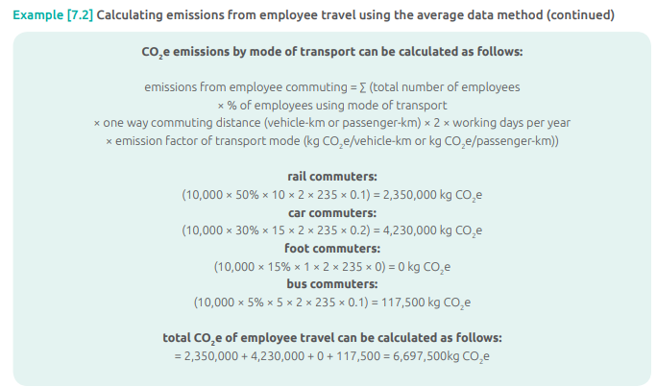

# 8, Upstream Leased Assets

Category 8 includes emissions from the operation of assets that are leased by the reporting company in the reporting year and not already included in the reporting company’s scope 1 or scope 2 inventories. This category is applicable only to companies that operate leased assets (i.e., lessees). For companies that own and lease assets to others (i.e., lessors), see category 13 (Downstream leased assets).

* **Asset-specific method,** which involves collecting asset-specific (e.g., site-specific) fuel and energy use data and process and fugitive emissions data or scope 1 and scope 2 emissions data from individual leased assets
* **Lessor-specific method,** which involves collecting the scope 1 and scope 2 emissions from lessor(s) and allocating emissions to the relevant leased asset(s)
* **Average data method,** which involves estimating emissions for each leased asset, or groups of leased assets, based on average data, such as average emissions per asset type or floor space.

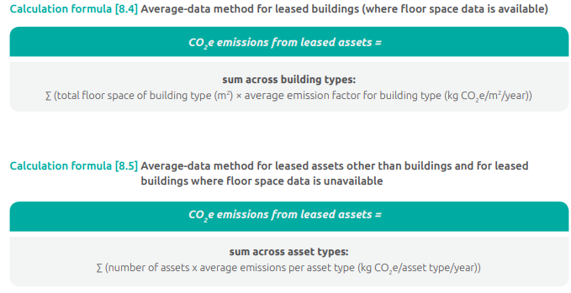

Data collection guidance The U.S. Energy Information Administration has developed a dataset on average energy use by building type. Commercial Buildings Energy Consumption Survey, at: <http://www.eia.doe.gov/emeu/cbecs>

# 9, Downstream Transportation and Distribution

This category includes emissions that occur in the reporting year from transportation and distribution of sold products in vehicles and facilities not owned or controlled by the reporting company.

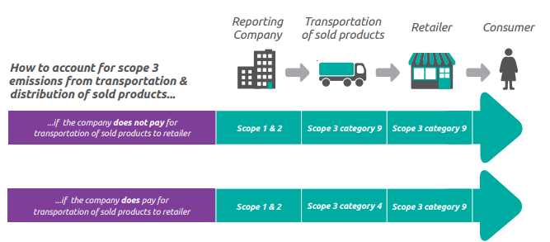

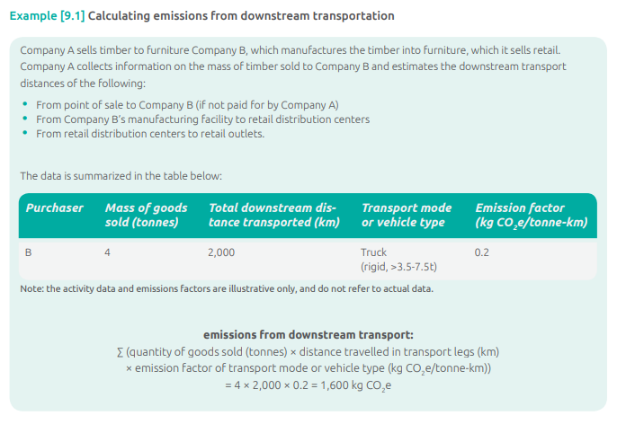

# 10, Processing of Sold Products

Category 10 includes emissions from processing of sold intermediate products by third parties (e.g., manufacturers) subsequent to sale by the reporting company. Intermediate products are products that require further processing, transformation, or inclusion in another product before use (see box 5.3 of the Scope 3 Standard), and therefore result in emissions from processing subsequent to sale by the reporting company and before use by the end consumer. Emissions from processing should be allocated to the intermediate product.

* **Site-specific method,** which involves determining the amount of fuel and electricity used and the amount of waste generated from processing of sold intermediate products by the third party and applying the appropriate emission factors
* **Average-data method,** which involves estimating emissions for processing of sold intermediate products based on average secondary data, such as average emissions per process or per product.

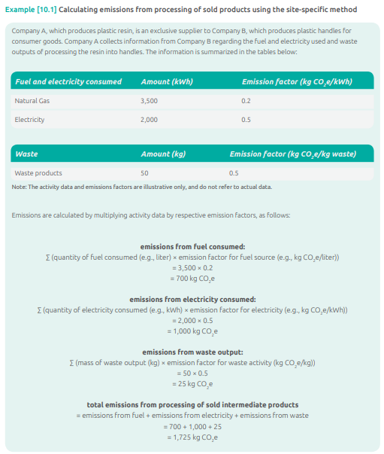

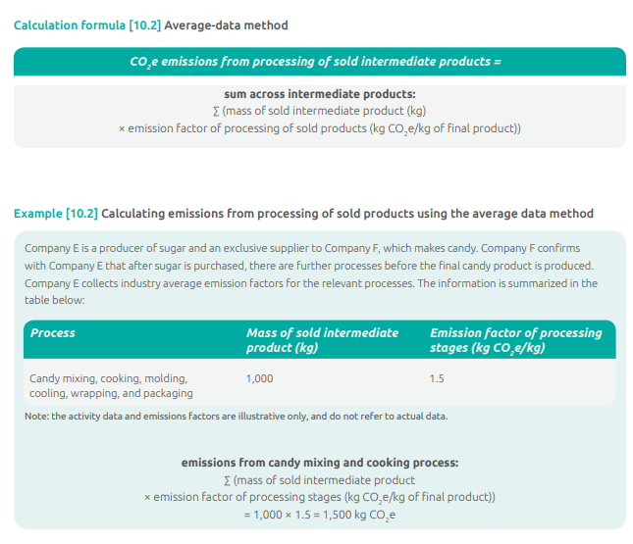

# 11, Use of Sold Products

This category includes emissions from the use of goods and services sold by the reporting company in the reporting year. A reporting company’s scope 3 emissions from use of sold products include the scope 1 and scope 2 emissions of end users. End users include both consumers and business customers that use final products.

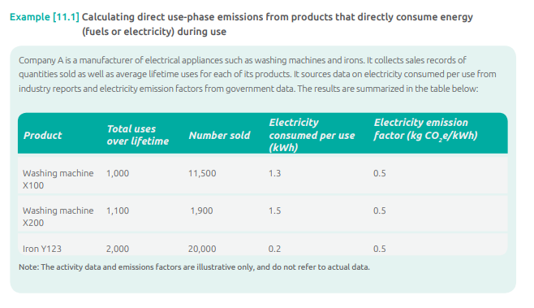

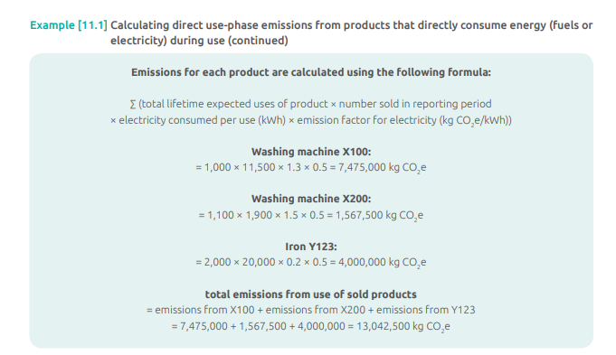

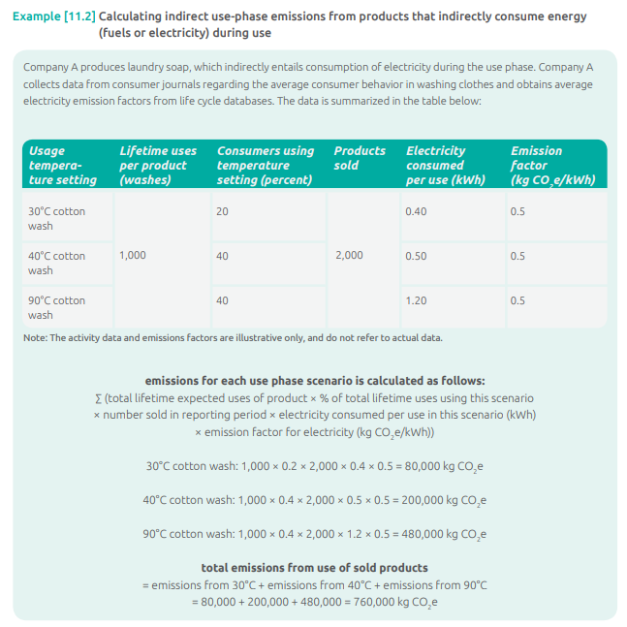

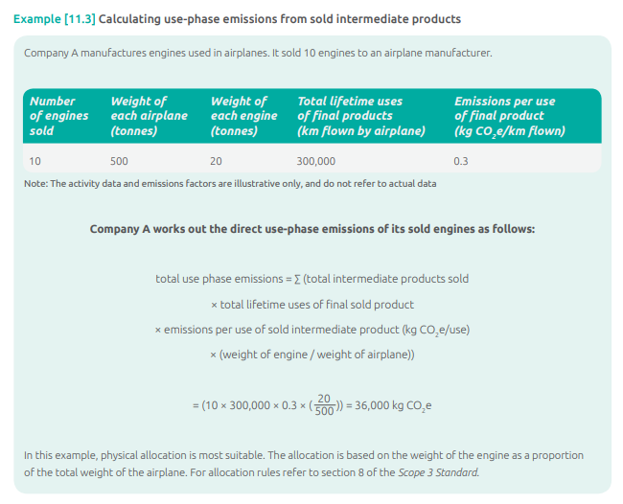

# 12, End-of-Life Treatment of Sold Products

Category 12 includes emissions from the waste disposal and treatment of products sold by the reporting company (in the reporting year) at the end of their life. This category includes the total expected end-of-life emissions from all products sold in the reporting year. (See section 5.4 of the Scope 3 Standard for more information on the time boundary of scope 3 categories.)

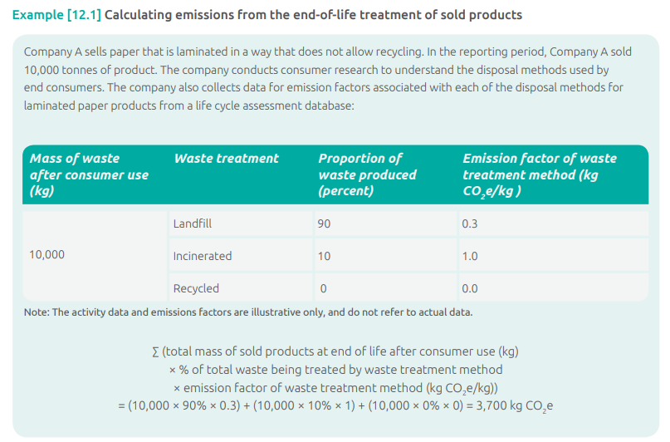

# 13, Downstream Leased Assets

This category includes emissions from the operation of assets that are owned by the reporting company (acting as lessor) and leased to other entities in the reporting year that are not already included in scope 1 or scope 2. This category is applicable to lessors (i.e., companies that receive payments from lessees). Companies that operate leased assets (i.e., lessees) should refer to category 8 (Upstream leased assets).

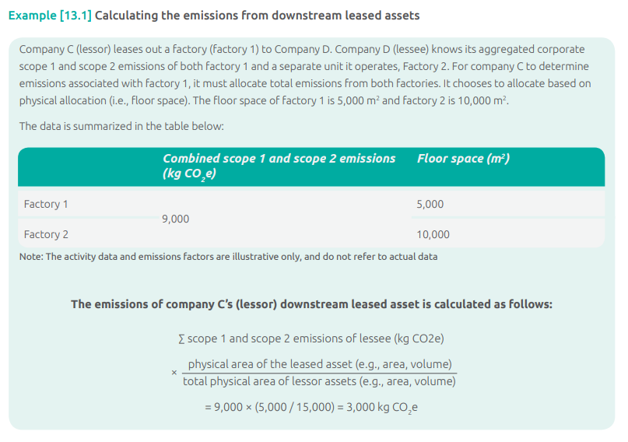

# 14, Franchises

Category 14 includes emissions from the operation of franchises not included in scope 1 or scope 2. A franchise is a business operating under a license to sell or distribute another company’s goods or services within a certain location. This category is applicable to franchisors (i.e., companies that grant licenses to other entities to sell or distribute its goods or services in return for payments, such as royalties for the use of trademarks and other services). Franchisors should account for emissions that occur from the operation of franchises (i.e., the scope 1 and scope 2 emissions of franchisees) in this category.

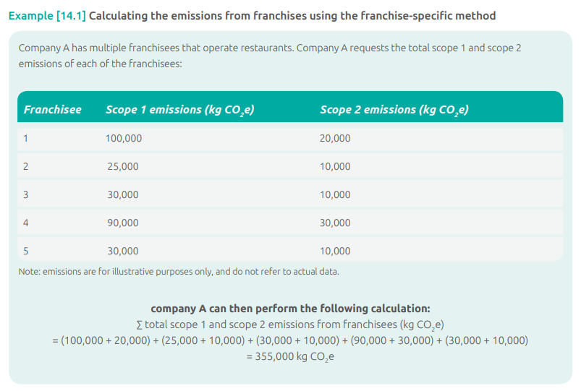

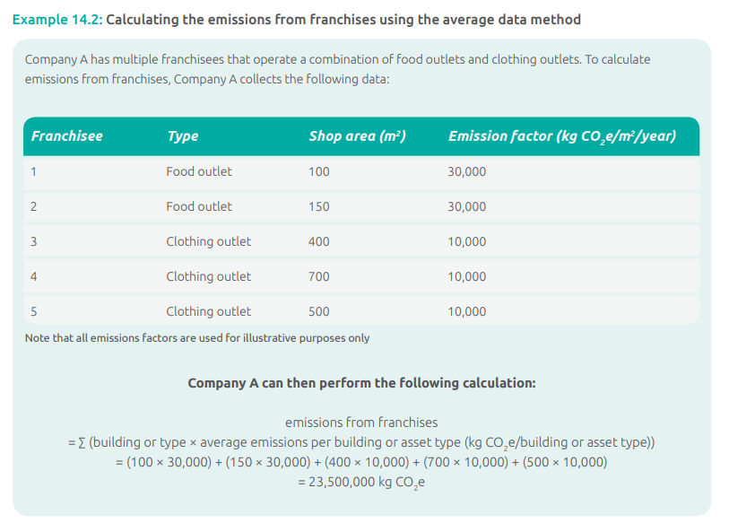

# 15, Investments

This category includes scope 3 emissions associated with the reporting company’s investments in the reporting year, not already included in scope 1 or scope 2. This category is applicable to investors (i.e., companies that make an investment with the objective of making a profit) and companies that provide financial services. This category also applies to investors that are not profit driven (e.g. multilateral development banks), and the same calculation methods should be used. Investments are categorized as a downstream scope 3 category because providing capital or financing is a service provided by the reporting company

